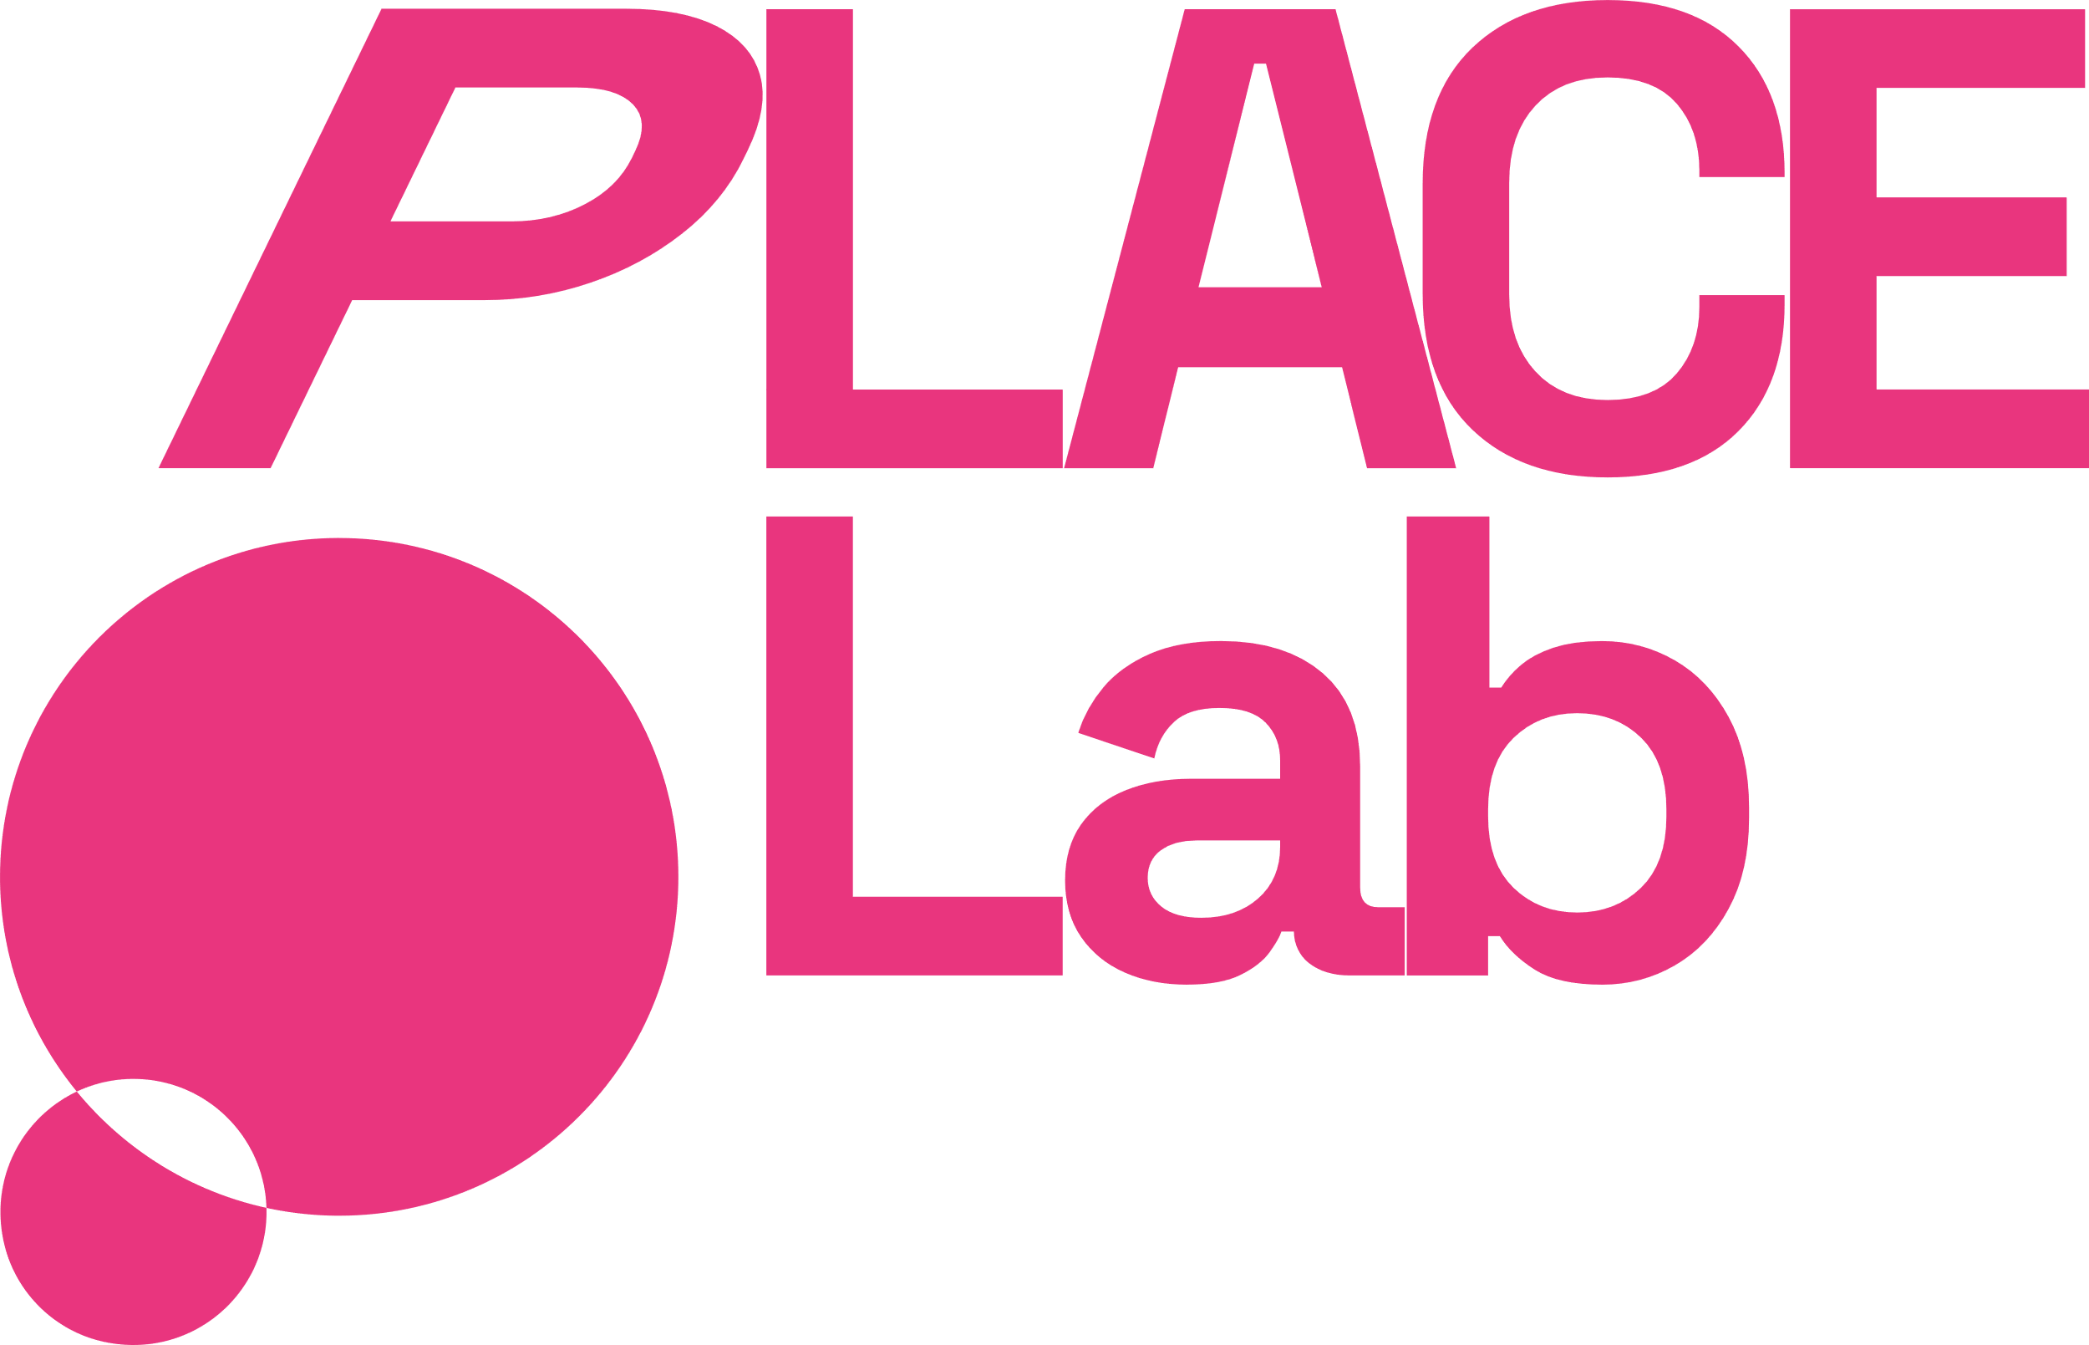
PLACE Lab Shildon 2025-26:
Artist Brief
A project working with young people to celebrate heritage and inspire futures. Including a ‘documentary’ approach to capturing these untold heritage stories with and alongside young people.
What we are looking for:
We are looking for a creative company or team to deliver a creative programme of activity designed with and created alongside young people in Shildon. The creative team will support young people to develop their skills and also include a wide range of young peoples’ voices to capture their thoughts, feelings and ambitions for the future.
We seek to appoint a creative team experienced in co-creating work for and with children and young people and who share our focus on including and supporting children and young people to articulate their voice, so as to influence the next phase (2026 - 2028) of a 10 year town-wide heritage programme in Shildon & Newton Aycliffe, County Durham.
We are looking for creative responses to the brief in, but not limited to, the following art forms:
- Filmmaking
- Photography
- Visual art
- Exhibitions & events
- Performance
We are looking for responses to the brief that might be inspired by, but not exclusively, the following ideas:
- Ingenuity, invention and new ideas
- Pushing boundaries, taking risks, and daring to dream
- Adventure, bringing people and places closer together through time and space, exploring new worlds
We are open to a combination of these and other approaches to realise the brief.
Fees & Materials Budget:
The total creative fee is £18,600, inc. VAT (if applicable)
Fees are all inclusive, including: all staff & freelancer costs, drop-in engagement activity, documentary/heritage inspired skills workshops, administration & budget management, meetings, partner liaison.
In addition, the following fees (inc. VAT) are available for the commissioned team, as required:
Access Support up to £500
Travel & Expenses up to £1,000
Materials up to £6,000
Northern Heartlands will manage separate budgets for venue hire, marketing & communications and evaluation & data.
The commissioned team may be an organisation, company or collective of individual artists & freelancers working together (please include one named point of contact in your proposal).

Between November 2025 and September 2026, the creative team (supported by staff at Northern Heartlands) will identify and work with a number of children and young people’s groups through workshops and other creative engagement opportunities. The creative team will support children and young people - via partnerships with existing groups and clubs - to share and explore their experiences of Shildon’s rich heritage, their living heritage and what that means for their future.
What is expected
The commissioned creative team will:
- Deliver high quality creative activity for and with children and young people that celebrates heritage and inspires futures
- Deliver drop-in engagement activity to gather children & young people’s voices and experiences of Shildon’s heritage (past, present and future)
- Create and post-produce a high quality artwork that represents the views and ideas of children & young people who’ve taken part in the above engagement activity
- Deliver more in depth ‘documentary’/heritage related skills workshops with a small number of groups
- Create a high quality work/document/film that can be shared easily and widely with stakeholders, partners and potential funders
- Collaborate with PLACE Lab : Shildon to realise a celebration and/or sharing of the final artwork. In Summer / early Autumn 2026, the artwork / activity will be shared with the commissioner (Durham County Council), their advisory group and our funders (National Lottery Heritage Fund and Arts Council England).
Additional Information:
Project Background:
The creative activity and resulting artwork will support the National Lottery Heritage Fund Heritage Places programme. The Heritage Places project aims to put heritage at the centre of place-based plans to transform local areas, helping to boost local pride and people's connection to their heritage. Durham County Council is the responsible body for the Heritage Place Programme
As part of the Heritage Places Programmes, this project is managed by Northern Heartlands via PLACE Lab : Shildon.
PLACE Lab Shildon is one of six PLACE Lab s in County Durham using the power of culture and creativity to catalyse change at a local level. PLACE Lab is part of Into the Light, a transformative programme of creative, collaborative projects across County Durham, funded by Arts Council England.
Participants
Participants will be aged approximately 5-12, with scope for the appointed creative team to work with younger children & their families and/or older children up to the age of 18.

The project is the first stage of an anticipated 10 year programme. The engagement targets outlined below are therefore indicative of the early stages of a place-based, partnership project:

- At least 50 children and/or young people share their voice (drop-in)
- At least 20 children and/or young people involved in skills workshops

Responses to the brief must take into account the limited time commitment that groups may have to take part. We are therefore looking for drop-in style engagement for children & young people that takes place within partners’ existing activities and venues. Documentary skills or skills that support heritage are also anticipated to take place within partners’ existing activities and venues (duration is to be mutually agreed).

Partners
The work will be created in partnership with children and young people’s groups, services and organisations based in Shildon.

Shildon offers a wide range of ways for children and young people to take part in the life and heritage of the community, from youth charities to community centres, primary schools to sports clubs, faith groups supporting children & their families to youth volunteering.

Local groups and organisations who have expressed an interest in joining the project include:

Shildon Town Council (community events), SCYPAN (children & young people’s groups membership), Jubilee Fields Community Association, Shildon AFC (youth teams), Locomotion, NHS Youth Work Team, Stage Point CIC, Durham County Council Sports Officers, Shildon Alive, Teesdale YMCA (Shildon Youth Group)

SHILDON’S HERITAGE/BACKGROUND:
Shildon heritage is entrenched with the development of the steam engine, and there are currently various events happening across Shildon and the wider area celebrating the 200 year anniversary of the Stockton to Darlington Railway. Often referred to as the 'cradle of the railways' it is here that the first steam hauled public train began its historic journey in 1825. The railway industry dominated the town until the abrupt closure of the Shildon Works in 1984. The town's connections with the birth of the railways are marked at Locomotion National Railway Museum, which has proved an extremely popular visitor attraction since opening in 2004. Shildon has a population of approximately 10,0793, with 7,131 of working age. Local employment has historically been reliant on the changing manufacturing sector. The average weekly household income is lower than the County and North East averages.
The programme could explore young people’s involvement with living heritage (cultural practices and traditions that are actively maintained and passed down through generations). We know that there is a Football Club in Shildon with lots of young people attending which was formed in 1890 and a Boxing Club which is also popular with young people which formed in 1903.

Proposal Process
Key Dates
22 August 2025 Artist Brief Open
16 September 2025, 15.00-16.00 Online Find Out More session (hosted by Northern Heartlands)
22 September 2025, 12noon Deadline for Applications
w/c 29 September 2025 Shortlisting
17 October 2025 Interviews (in person at N Heartlands office)
By 31 October 2025 Commissioned Creative Team Appointed
November 2025 Briefing & Initial Partner Meetings
December 2025 Project Delivery Begins
July - September 2026 Sharing Moment
September - October 2026 Review and Project Complete

How to Apply
To respond to the brief, please send the following:
Up to 2 pages A4 or 5 minutes video/audio:
- Outlining your response and proposed approach to the brief
- Timeline
- Budget

In a separate document please also attach:
- Information about the team including skills and experience (e.g. names & roles, website links, 2-3 examples of relevant projects)
- Name and contact details of 2 referees ( we won’t contact referees before appointing)

