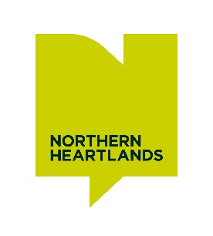

Creatively Connected – Artist Brief SUMMARY
An exciting opportunity for four experienced artists to work collaboratively on an inspiring programme of creative activity in Teesdale (County Durham) and Swaledale (North Yorkshire).

Each artist will receive a commission of £21,800 (50 days including materials, travel and expenses)

We are looking to appoint four creative practitioners to undertake concurrent residencies between September 2024 and September 2025.

You will develop work through a collaborative, enquiry-based process that responds to the landscapes and the issues being addressed by the Tees-Swale programme.

As well as sharing ideas and approaches with other creative practitioners, you will work with communities, the Tees-Swale team and wider audiences, using your artistic practice to develop conversations around hill-farming, conservation, environmental issues and the landscape.

Together you will explore alternative ways to connect, question and imagine the future.

We are looking for:
- A strong track record of enquiry based creative practice in any artform and at least three years experience of similar work
- A strong track record of enquiry-based creative practice in any artform and at least three years’ experience of similar work.
- Experience of innovative approaches to engagement, and encouraging curiosity with communities and partners
- Evidence of your ability to reflect on your practice, learn from your process and share that learning with others
- Some knowledge and experience of working with rural communities and within natural landscape settings
- Some understanding of the issues facing farmers, landowners, ecologists and environmentalists.
- Public liability insurance >£5million
- Current DBS (we can support with an application for this)

Timeline:
Shortlisting and election of artists | July 2024
Interviews | 29th and 30th August 2024
Artis briefing/site visits | September/October 2024
Research and development | October 2024 – January 2025
Delivery | Jan – July 2025

CREATIVELY CONNECTED is a discrete project funded by Arts Council England (ACE) and the National Lottery Heritage Fund (NLHF) within a wider programme focussing on high nature value farming:
TEES-SWALE:NATURALLY CONNECTED, an £8.5m collaboration between the Yorkshire Dales National Park Authority (YDNPA) and North Pennines National Landscapes (NPNL).
The Tees-Swale programme began in 2019 and is due to finish before March 2025.

