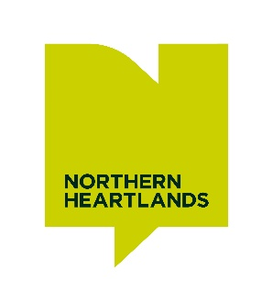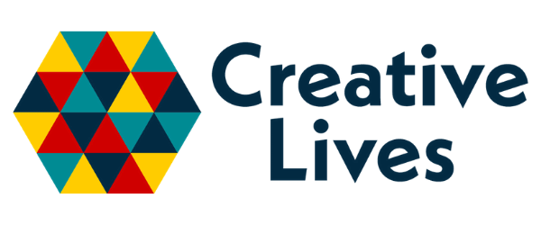
TAKE PART IN TEESDALE
Supporting improved health and wellbeing through creativity

The Project

The Take Part in Teesdale project is designed to support adults in Teesdale living with health and wellbeing related needs through creativity and arts-led enquiry. Adults will work with and alongside creative practitioners to explore their own ideas, develop their creativity and create new work through a range of different art forms.

In addition, this project provides resources and funding to support creative practitioners to undertake shared action learning and attend training sessions to support the facilitation of creative health work. This training might include mental health first aid training or other training sessions that support creative health practices.

Funding also allows for joint facilitation. For example, two creative practitioners might work together to plan and deliver a session, or a creative practitioner might attend a session being facilitated to ‘observe’, share ideas and reflect on methods that can support creative health practice development.

We will work with a cohort of up to 4 creative practitioners to develop a coherent programme that supports improved health and wellbeing outcomes and supports the practice and development of creative health with creative practitioners.

The Brief

We are looking for creative practitioners whose practice focuses on creative health outcomes that can support adults living with mild mental health issues/chronic loneliness/anxiety or depression. We are looking to work with creative practitioners who are interested in sharing learning and developing their creative health practices.

The creative practitioner-facilitated sessions will encourage creative enquiry and encourage participants to explore their own skills and ideas. This could involve a range of creative techniques and art forms that offer participants a variety of experiences.

- The project will take place between 3rd November 2025 and be completed by 16th February 2026.
- Sessions will take place in Barnard Castle – a central location with good transport links.
- Sessions will run on Monday afternoons from 13.00-15.00.
- Sessions will take place in an accessible church hall on the high street
- We will be supported by Social Prescribing Link Workers to help identify participants to take part.

The role of Northern Heartlands

- Sessions will be fully supported by a member of the Northern Heartlands’ team who will be responsible for recruiting participants and supporting their wellbeing needs during sessions.

- We are offering this opportunity to experienced creative practitioners or those interested in developing their creative health practice for specific wellbeing/mental health outcomes.

- We will be gathering feedback from participants to understand any improvements in health and wellbeing outcomes through this approach.

- Work created by participants might be shared in a small exhibition in a local venue which Northern Heartlands will coordinate.

Budget
This includes:
Fee: for 3-hour sessions (including half hour set up/get out and 2-hour delivery), per artist: £150/session for up to 15 sessions
1 x half day preparation session: £150 per artist
1x half day reflection and evaluation session: £150 per artist
Materials: £30 / session
Training and Development: fee to be confirmed including sharing and/or co-facilitated sessions

What we mean by ‘Creative Health’

Defined by the National Centre for Creative Health, creative health involves “creative approaches and activities which have benefits for our health and wellbeing.” Creative health refers to the strategic use of creative and cultural activities (such as music, visual arts, dance, writing, and heritage engagement) to improve and sustain health and wellbeing across individuals, communities, and systems. It is not just about participating in the arts but about integrating creativity into the design and delivery of health and care services, public health strategies, and community development. This practice is evidence-based and offers measurable health outcomes.

